QR CODE AND SECURED BLOCK CHAIN BASED PRODUCT VERIFICATION
ABSTRACT
Counterfeit products pose significant challenges to businesses and consumers, leading to financial losses and safety concerns. This project presents a robust solution by integrating QR code technology and blockchain to ensure product authenticity and traceability. Developed using Python Flask and MySQL, the system involves three key stakeholders: Manufacturers, Sellers, and Customers.
The Manufacturer adds product details to the system and generates a unique QR code for each product. When a product is sold to a Seller, transaction details—including the Manufacturer ID, QR code number, and Seller ID—are stored securely in a custom-designed blockchain ledger. The blockchain ensures immutability and transparency of transaction data, making it resistant to tampering.
Customers can verify the authenticity of their purchased products by scanning the QR code. The system cross-verifies the scanned QR code with data stored in the blockchain. If the QR code is found and matches the blockchain record, the product is deemed legitimate. Otherwise, it is flagged as a counterfeit product.
This system enhances product verification processes, ensuring trust and reliability across the supply chain. By leveraging the decentralization and security features of blockchain technology combined with the ease of QR code scanning, the solution provides a scalable and efficient way to combat counterfeit goods.

INTRODUCTION
The proliferation of counterfeit products in the global market has become a critical issue, impacting businesses, consumers, and economies. Counterfeit goods not only lead to revenue losses for manufacturers and sellers but also pose significant risks to consumer safety and trust. Addressing this challenge requires an innovative approach to ensure product authenticity, transparency, and traceability throughout the supply chain.
This project introduces a QR Code and Blockchain-Based Product Verification System, designed to provide a secure and efficient method to authenticate products. By combining QR code technology for easy product identification with a custom blockchain for secure data storage, the system offers a comprehensive solution to mitigate the risks of counterfeit goods.
The system consists of three primary stakeholders:
- Manufacturers: Responsible for adding product details to the system and generating unique QR codes for each product.
- Sellers: Act as intermediaries who receive products from manufacturers, with transaction details recorded on the blockchain.
- Customers: Verify the authenticity of products by scanning the QR code and cross-checking it with blockchain data.
When a manufacturer sells a product to a seller, the transaction details, including the manufacturer ID, QR code, and seller ID, are securely recorded in the blockchain. Customers can verify the product's authenticity by scanning its QR code. If the code matches the blockchain record, the product is confirmed as genuine. If the code is not found in the blockchain, the product is flagged as counterfeit.
This innovative system not only deters counterfeit activities but also enhances consumer confidence by providing a transparent and tamper-proof mechanism for product verification. By leveraging the security and immutability of blockchain technology combined with the simplicity of QR code scanning, the system addresses the challenges of counterfeit goods in a scalable and user-friendly manner.

PROBLEM STATEMENT
The rise of counterfeit products in the market poses a significant threat to manufacturers, sellers, and consumers. Counterfeiting not only causes financial losses for businesses but also undermines consumer trust and poses risks to health and safety, particularly in industries like pharmaceuticals, electronics, and luxury goods. Traditional methods of product verification are often manual, inefficient, and susceptible to tampering, making them inadequate to combat the growing sophistication of counterfeit operations.
Key challenges include:
- Lack of Transparency: Current supply chain systems often lack a transparent and reliable mechanism to track product authenticity from manufacturer to end-user.
- Product Counterfeiting: Fake products flood the market, making it difficult for consumers to differentiate between genuine and counterfeit goods.
- Data Tampering: Centralized systems for product authentication are vulnerable to manipulation and unauthorized modifications.
- Consumer Inconvenience: Manual verification processes, if available, are cumbersome and fail to provide real-time results.
To address these issues, there is a need for an efficient, tamper-proof, and user-friendly system that ensures product authenticity and builds trust among stakeholders.

PROPOSED SYSTEM
The proposed system integrates QR code technology and blockchain to provide a secure, transparent, and efficient mechanism for product verification. It aims to address the issues of counterfeit goods by creating a decentralized and tamper-proof system that involves key stakeholders: Manufacturers, Sellers, and Customers.

Key Features of the System:
- Product Registration by Manufacturer:
  - Manufacturers register products in the system by adding product details such as product name, description, and unique identifiers.
  - A unique QR code is generated for each product, linking it to its specific details.
- Blockchain Integration:
  - Transactions between stakeholders are recorded on a custom blockchain ledger.
  - Whenever a product is sold from the manufacturer to the seller, the system logs the transaction details, including:
    - Manufacturer ID
    - Seller ID
    - QR code
    - Timestamp
  - The blockchain ensures data immutability and transparency, preventing tampering or unauthorized modifications.
- Product Verification by Customers:
  - Customers verify the authenticity of their purchased products by scanning the QR code using the system.
  - The QR code is cross-checked with the blockchain database:
    - If the QR code matches a valid record, the product is confirmed as genuine.
    - If the QR code is not found, the product is flagged as counterfeit.
- Decentralized Security:
  - The blockchain's decentralized nature ensures data security, making the system resilient to unauthorized access or alterations.
- User-Friendly Interface:
  - The system is developed using Python Flask for the backend and a MySQL database for data storage.
  - It provides an intuitive and accessible interface for all stakeholders, ensuring seamless interaction.

Workflow:
- Manufacturer Stage:
  - Add product details and generate a unique QR code.
  - Record the sale of products to sellers on the blockchain.
- Seller Stage:
  - Receive products and manage sales to customers.
  - Serve as intermediaries with no access to modify blockchain data.
- Customer Stage:
  - Scan the QR code on purchased products.
  - Verify the product's authenticity through blockchain validation.

Advantages of the Proposed System:
- Security: Blockchain ensures data integrity and prevents tampering.
- Transparency: All transactions are traceable and verifiable by stakeholders.
- Efficiency: QR codes provide a quick and user-friendly way to verify products.
- Trust Building: Customers gain confidence in the authenticity of their purchases.
This system provides a comprehensive solution to combat counterfeit goods, enhancing trust and reliability across the supply chain while ensuring a seamless and secure product verification process.

FUNCTIONAL AND NON FUNCTIONAL REQUIREMENTS

🔹 Functional Requirements

1. Manufacturer Module
- Register/Login to the system.
- Add product details (e.g., product name, serial number, manufacturing date, etc.).
- Generate a unique QR code for each product.
- Transfer product ownership to sellers with transaction details recorded on the blockchain.

2. Seller Module
- Register/Login to the system.
- Receive products from manufacturers and verify QR codes.
- View transaction history of received products.
- Sell products to customers while maintaining blockchain transaction logs.

3. Customer Module
- Scan the QR code on a purchased product using a web or mobile interface.
- Validate the product authenticity by checking it against blockchain records.
- Receive an alert if the product is counterfeit.

4. Blockchain Ledger
- Store transaction records (Manufacturer ID, QR Code, Seller ID, Timestamp, etc.).
- Ensure immutability of product transactions.
- Allow verification of data integrity and ownership history.

5. Admin Module (Optional)
- Manage manufacturers and sellers.
- View system logs and blockchain transactions for auditing.

🔹 Non-Functional Requirements

1. Security
- Ensure data integrity using blockchain technology.
- Implement authentication & authorization (e.g., JWT for APIs).
- Secure QR code generation & verification to prevent duplication.

2. Performance & Scalability
- The system should handle a large number of QR code scans efficiently.
- Blockchain should scale to support multiple manufacturers and sellers.

3. Usability
- Provide an easy-to-use UI for manufacturers, sellers, and customers.
- QR code scanning should be fast and seamless using mobile/web apps.

4. Reliability & Availability
- Ensure high uptime and fault tolerance of blockchain nodes.
- Data should always be available for verification by customers.

5. Maintainability & Extensibility
- Modular codebase for easy updates (e.g., adding more security layers).
- Support for future integrations (e.g., AI-based product verification).

SYSTEM REQUIREMENTS

SOFTWARE REQUIREMENTS
OPERATING SYSTEM | WINDOWS 10+
LANGUAGE | PYTHON
IDE | VS CODE
DATABASE | MYSQL
DATABASE TOOLS | HEIDI SQL

HARDWARE REQUIREMENTS
RAM | 4GB
HDD | 20GB
PROCESSOR | INTEL I5

ABOUT TOOLS AND TECHNOLOGIES USED
ABOUT PYTHON
Python offers concise and readable code. While complex algorithms and versatile workflows stand behind machine learning and AI, Python’s simplicity allows developers to write reliable systems. Developers get to put all their effort into solving an ML problem instead of focusing on the technical nuances of the language.
Additionally, Python is appealing to many developers as it’s easy to learn. Python code is understandable by humans, which makes it easier to build models for machine learning.
Many programmers say that Python is more intuitive than other programming languages. Others point out the many frameworks, libraries, and extensions that simplify the implementation of different functionalities. It’s generally accepted that Python is suitable for collaborative implementation when multiple developers are involved. Since Python is a general-purpose language, it can do a set of complex machine learning tasks and enable you to build prototypes quickly that allow you to test your product for machine learning purposes.

Platform independence
Platform independence refers to a programming language or framework allowing developers to implement things on one machine and use them on another machine without any (or with only minimal) changes. One key to Python’s popularity is that it’s a platform independent language. Python is supported by many platforms including Linux, Windows, and macOS. Python code can be used to create standalone executable programs for most common operating systems, which means that Python software can be easily distributed and used on those operating systems without a Python interpreter.
What’s more, developers usually use services such as Google or Amazon for their computing needs. However, you can often find companies and data scientists who use their own machines with powerful Graphics Processing Units (GPUs) to train their ML models. And the fact that Python is platform independent makes this training a lot cheaper and easier.

Great community and popularity
In the Developer Survey 2018 by Stack Overflow, Python was among the top 10 most popular programming languages, which ultimately means that you can find and hire a development company with the necessary skill set to build your AI-based project.
If you look closely at the image below, you’ll see that Python is the language that people Google more than any other.

PYTHON INSTALLATION
Python is a widely used high-level programming language. To write and execute code in python, we first need to install Python on our system.
Installing Python on Windows takes a series of few easy steps.

Step 1 − Select Version of Python to Install
Python has various versions available with differences between the syntax and working of different versions of the language. We need to choose the version which we want to use or need. There are different versions of Python 2 and Python 3 available.

Step 2 − Download Python Executable Installer
On the web browser, in the official site of python (www.python.org), move to the Download for Windows section.
All the available versions of Python will be listed. Select the version required by you and click on Download. Let suppose, we chose the Python 3.9.1 version.
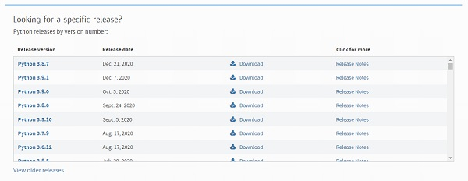
On clicking download, various available executable installers shall be visible with different operating system specifications. Choose the installer which suits your system operating system and download the instlaller. Let suppose, we select the Windows installer(64 bits).
The download size is less than 30MB.
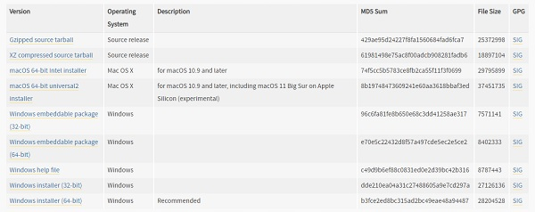

Step 3 − Run Executable Installer
We downloaded the Python 3.9.1 Windows 64 bit installer.
Run the installer. Make sure to select both the checkboxes at the bottom and then click Install New.
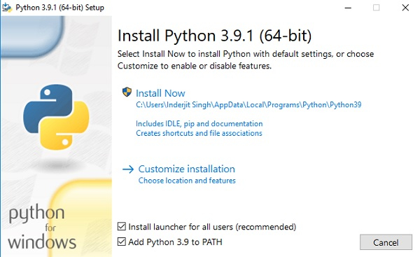
On clicking the Install Now, The installation process starts.
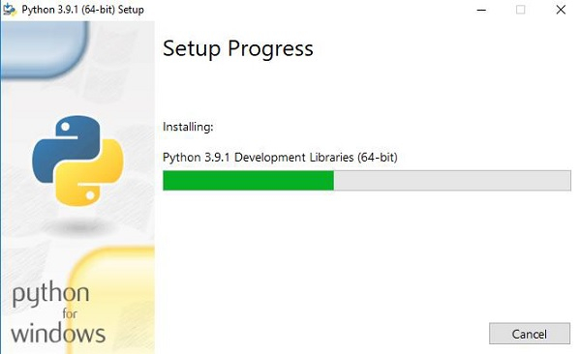
The installation process will take few minutes to complete and once the installation is successful, the following screen is displayed.
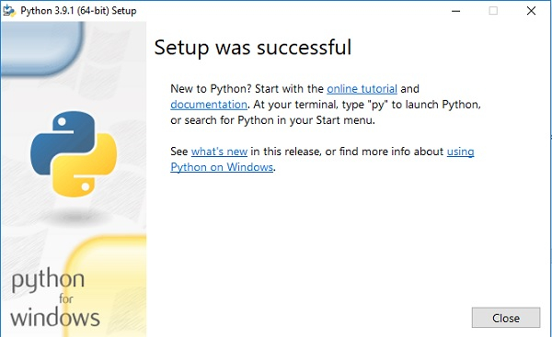

Step 4 − Verify Python is installed on Windows
To ensure if Python is succesfully installed on your system. Follow the given steps −
- Open the command prompt.
- Type ‘python’ and press enter.
- The version of the python which you have installed will be displayed if the python is successfully installed on your windows.
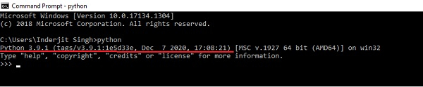

Step 5 − Verify Pip was installed
Pip is a powerful package management system for Python software packages. Thus, make sure that you have it installed.
To verify if pip was installed, follow the given steps −
- Open the command prompt.
- Enter pip –V to check if pip was installed.
- The following output appears if pip is installed successfully.
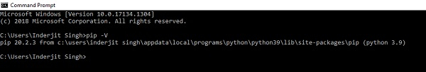
We have successfully installed python and pip on our Windows system.

To install any libraries
Go to command prompt
Type
Pip install libraryname

VS CODE IDE
Visual Studio Code (VS Code) is a free, open-source, and powerful code editor developed by Microsoft. It is widely used by developers for writing, editing, and debugging code in various programming languages. VS Code is highly customizable, lightweight, and includes a rich set of features, making it a popular choice for developers working on both small and large-scale projects.

Key Features of Visual Studio Code:
- Cross-Platform:
  - VS Code is available on Windows, macOS, and Linux, allowing developers to use the same editor across different operating systems.
- IntelliSense:
  - This feature provides smart code completion, parameter info, quick info, and member lists, making it easier to write code with fewer errors and more efficiency.
  - IntelliSense supports various languages, including JavaScript, Python, Java, and C++, among others.
- Integrated Terminal:
  - VS Code includes an integrated terminal that allows developers to run command-line scripts, such as running a server, executing build tasks, or interacting with version control (e.g., Git), directly within the editor.
- Version Control Integration:
  - VS Code has built-in support for Git. Developers can easily manage source control, commit changes, view diffs, and resolve merge conflicts within the editor.
  - It also supports other version control systems with extensions.
- Extensions and Customization:
  - VS Code has a vast marketplace of extensions that enhance functionality. Developers can install extensions for additional language support, linters, debuggers, themes, and tools like Docker, Kubernetes, and more.
  - The editor can be customized with different themes, icon sets, and other UI adjustments.
- Debugger:
  - VS Code provides a powerful debugging experience with support for breakpoints, call stacks, and variable inspection.
  - It supports debugging for many languages (e.g., JavaScript, Python, C++, Node.js, etc.) through extensions and built-in features.
- Support for Multiple Languages:
  - VS Code supports a wide range of programming languages, such as Python, JavaScript, HTML, CSS, Java, C++, Go, PHP, and many more. Additional languages can be added via extensions.
- Syntax Highlighting:
  - VS Code supports syntax highlighting for many programming languages, improving code readability and reducing errors during development.
- Live Preview:
  - For web developers, VS Code allows live preview of HTML, CSS, and JavaScript files. You can see real-time changes directly in the browser as you edit code.
- Code Navigation:
  - Features like “Go to Definition,” “Find References,” and “Peek Definition” allow developers to navigate through code quickly and easily, enhancing productivity.
- Code Snippets:
  - VS Code allows you to create and use code snippets, which are reusable blocks of code that you can quickly insert into your files, speeding up coding for repetitive tasks.
- Multiple File and Split View:
  - You can work with multiple files simultaneously in a split view, making it easier to compare files or work on different parts of the project at once.
- Task Runner:
  - VS Code supports task automation, allowing developers to define tasks for building, testing, and running code directly from the editor.
- Remote Development:
  - VS Code provides features for remote development, allowing developers to connect to a remote server or container and edit code from there without needing to leave the editor.

Extensions and Customization:
VS Code has a large library of extensions that provide additional functionality, such as:
- Language Support: Extensions for languages like Python, Ruby, C++, Java, PHP, etc.
- Themes: Custom themes for a personalized code editing environment.
- Linters and Formatters: Extensions that check code quality and enforce coding standards (e.g., ESLint for JavaScript, Pylint for Python).
- GitHub and Git Extensions: Enhanced Git functionality for version control integration.
- Docker: Extensions to manage Docker containers and images from within VS Code.
- Prettier: A code formatter that ensures consistent code style.
- Python: A full-featured extension to support Python development, including linting, debugging, and virtual environment management.

Advantages of Using VS Code:
- Lightweight and Fast:
  - Despite its rich features, VS Code is lightweight and starts quickly, making it ideal for a wide range of development needs.
- Highly Customizable:
  - Developers can tailor VS Code to suit their preferences, from appearance (themes, icons) to functionality (extensions, keyboard shortcuts).
- Free and Open Source:
  - VS Code is free to use and open source, making it an excellent choice for individuals and teams of all sizes.
- Active Community:
  - VS Code has a large and active community of developers who create extensions, contribute to the development, and offer support.
- Excellent Debugging and Testing:
  - VS Code's integrated debugging tools provide a seamless experience for troubleshooting and testing code.
- Integration with Other Tools:
  - VS Code integrates well with tools like Git, Docker, Azure, and various cloud services, making it a robust option for full-stack development.
- Multi-Language Support:
  - With VS Code, developers can easily switch between different programming languages and use the same editor for various tasks, whether it's frontend, backend, or data science work.

How to Install and Use VS Code:
- Installation:
  - Visit the official Visual Studio Code website to download the appropriate version for your operating system (Windows, macOS, or Linux).
  - Follow the installation instructions based on your OS.
- Using VS Code:
  - After installation, launch VS Code and start creating your project by opening folders or files.
  - Install relevant extensions for the programming languages you use.
  - Use the integrated terminal, open multiple files, and take advantage of VS Code’s intelligent code completion and debugging features.

Conclusion:
Visual Studio Code is one of the most popular code editors today, providing an outstanding balance of functionality, speed, and flexibility. Whether you're a beginner or an experienced developer, VS Code’s features and wide range of extensions make it a powerful tool for web development, software engineering, data science, and many other programming tasks. Its user-friendly interface, coupled with advanced debugging and version control features, makes it a top choice for developers across the globe.

FLASK

What is Flask Python
Flask is a web framework, it’s a Python module that lets you develop web applications easily. It’s has a small and easy-to-extend core: it’s a microframework that doesn’t include an ORM (Object Relational Manager) or such features.
It does have many cool features like url routing, template engine. It is a WSGI web app framework.

What is a Web Framework?
A Web Application Framework or a simply a Web Framework represents a collection of libraries and modules that enable web application developers to write applications without worrying about low-level details such as protocol, thread management, and so on.

What is Flask?
Flask is a web application framework written in Python. It was developed by Armin Ronacher, who led a team of international Python enthusiasts called Poocco. Flask is based on the Werkzeg WSGI toolkit and the Jinja2 template engine.Both are Pocco projects.

WSGI
The Web Server Gateway Interface (Web Server Gateway Interface, WSGI) has been used as a standard for Python web application development. WSGI is the specification of a common interface between web servers and web applications.

Werkzeug
Werkzeug is a WSGI toolkit that implements requests, response objects, and utility functions. This enables a web frame to be built on it. The Flask framework uses Werkzeg as one of its bases.

jinja2
jinja2 is a popular template engine for Python.A web template system combines a template with a specific data source to render a dynamic web page.
This allows you to pass Python variables into HTML templates like this:
<html>
<head>
<title>{{ title }}</title>
</head>
<body>
<h1>Hello {{ username }}</h1>
</body>
</html>

Microframework
Flask is often referred to as a microframework. It is designed to keep the core of the application simple and scalable.
Instead of an abstraction layer for database support, Flask supports extensions to add such capabilities to the application.

Why is Flask a good web framework choice?
Unlike the Django framework, Flask is very Pythonic. It’s easy to get started with Flask, because it doesn’t have a huge learning curve.
On top of that it’s very explicit, which increases readability. To create the “Hello World” app, you only need a few lines of code.
This is a boilerplate code example.
from flask import Flask
app = Flask(__name__)
@app.route('/')
def hello_world():
return 'Hello World!'
if __name__ == '__main__':
app.run()
If you want to develop on your local computer, you can do so easily. Save this program as server.py and run it with python server.py.
$ python server.py
* Serving Flask app "hello"
* Running on http://127.0.0.1:5000/ (Press CTRL+C to quit)
It then starts a web server which is available only on your computer. In a web browser open localhost on port 5000 (the url) and you’ll see “Hello World” show up.
To host and develop online, you can use PythonAnywhere
Some example output:
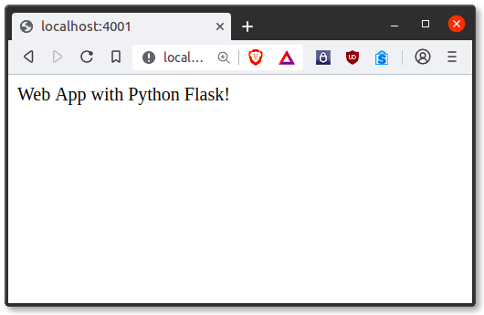
It’s a microframework, but that doesn’t mean your whole app should be inside one single Python file. You can and should use many files for larger programs, to handle complexity.
Micro means that the Flask framework is simple but extensible. You may all the decisions: which database to use, do you want an ORM etc, Flask doesn’t decide for you.
Flask is one of the most popular web frameworks, meaning it’s up-to-date and modern. You can easily extend it’s functionality. You can scale it up for complex applications

HTML
Hypertext Markup Language (HTML) is the standard markup language for creating web pages and web applications. With Cascading Style Sheets (CSS) and JavaScript, it forms a triad of cornerstone technologies for the World Wide Web.
Web browsers receive HTML documents from a web server or from local storage and render the documents into multimedia web pages. HTML describes the structure of a web page semantically and originally included cues for the appearance of the document.
HTML elements are the building blocks of HTML pages. With HTML constructs, images and other objects such as interactive forms may be embedded into the rendered page. HTML provides a means to create structured documents by denoting structural semantics for text such as headings, paragraphs, lists, links, quotes and other items. HTML elements are delineated by tags, written using angle brackets. Tags such as <img /> and <input /> directly introduce content into the page. Other tags such as <p> surround and provide information about document text and may include other tags as sub-elements. Browsers do not display the HTML tags, but use them to interpret the content of the page.
HTML can embed programs written in a scripting language such as JavaScript, which affects the behavior and content of web pages. Inclusion of CSS defines the look and layout of content. The World Wide Web Consortium (W3C), maintainer of both the HTML and the CSS standards, has encouraged the use of CSS over explicit presentational HTML since 1997.
CSS
Cascading Style Sheets (CSS) is a style sheet language used for describing the presentation of a document written in a markup language like HTML. CSS is a cornerstone technology of the World Wide Web, alongside HTML and JavaScript.
CSS is designed to enable the separation of presentation and content, including layout, colors, and fonts. This separation can improve content accessibility, provide more flexibility and control in the specification of presentation characteristics, enable multiple web pages to share formatting by specifying the relevant CSS in a separate .css file, and reduce complexity and repetition in the structural content.
Separation of formatting and content also makes it feasible to present the same markup page in different styles for different rendering methods, such as on-screen, in print, by voice (via speech-based browser or screen reader), and on Braille-basedtactile devices. CSS also has rules for alternate formatting if the content is accessed on a mobile device.
The name cascading comes from the specified priority scheme to determine which style rule applies if more than one rule matches a particular element. This cascading priority scheme is predictable.
The CSS specifications are maintained by the World Wide Web Consortium (W3C). Internet media type (MIME type) text/css is registered for use with CSS by RFC 2318 (March 1998). The W3C operates a free CSS validation service for CSS documents.
In addition to HTML, other markup languages support the use of CSS, including XHTML, plain XML, SVG, and XUL.

BLOCK CHAIN

1. What is Blockchain?
A blockchain is a decentralized, distributed digital ledger that records transactions across multiple computers in such a way that the recorded transactions cannot be altered retroactively. This makes it secure, transparent, and tamper-proof.
Each block in a blockchain contains:
- A unique identifier called a hash
- A reference to the previous block’s hash
- Transaction data (e.g., seller ID, product ID, manufacturer ID, etc.)
- A timestamp
Blocks are linked together using cryptographic hashes, forming a chain. This ensures immutability and prevents unauthorized modifications.

2. How is Blockchain Secured?
🔹 Cryptographic Hashing
- Every block contains a SHA-256 hash, which is unique and dependent on the block’s content.
- If a block’s data is changed, the hash changes, making it evident that tampering has occurred.
🔹 Immutability & Tamper Resistance
- Each block contains the hash of the previous block.
- Changing any block will invalidate the hashes of all following blocks, preventing unauthorized alterations.
🔹 Decentralization (Not implemented in our code, but relevant in public blockchains)
- In large-scale blockchains like Bitcoin or Ethereum, data is stored across multiple nodes (computers), reducing the risk of a single point of failure.
🔹 Consensus Mechanisms (Not included in our simple blockchain)
- Public blockchains use Proof of Work (PoW) or Proof of Stake (PoS) to prevent fraudulent transactions.
- In our case, we assume a trusted environment without the need for consensus mechanisms.

🔹 How We Designed the Blockchain in Python

1. Block Structure (Block Class)
Each block contains:
- index: Position of the block in the chain.
- timestamp: The time when the block was created.
- sellerid: Seller ID to track ownership.
- mid: Manufacturer ID to track origin.
- pid: Product ID for product verification.
- previous_hash: The hash of the previous block, ensuring chain continuity.
- hash: The computed SHA-256 hash of the block’s content.
✅ Security Feature: Each block’s hash is generated using calculate_hash(), ensuring integrity.

2. Blockchain Structure (Blockchain Class)
The Blockchain class manages the sequence of blocks.

A. Genesis Block (First Block in the Chain)
The first block (index 0) is manually created with a previous hash of "0":
def create_genesis_block(self):
genesis_block = Block(0, time(), None, None, None, "0")
self.chain.append(genesis_block)
✅ Security Feature: A predefined genesis block ensures a consistent starting point.

B. Adding a New Block (add_block Method)
A new block is added with seller ID, manufacturer ID, and product ID:
def add_block(self, sellerid, mid, pid):
previous_block = self.chain[-1]
new_block = Block(len(self.chain), time(), sellerid, mid, pid, previous_block.hash)
self.chain.append(new_block)
✅ Security Feature:
- The new block’s previous_hash is set to the hash of the last block to maintain integrity.
- This ensures that tampering with a block affects all subsequent blocks.

C. Saving & Loading Blockchain (save_chain & load_chain)
The blockchain is stored in a pickle file (blockchain_data.pkl) for persistence.
- Save Blockchain:
- def save_chain(self):
- with open('blockchain_data.pkl', 'wb') as file:
- pickle.dump(self.chain, file)
✅ Benefit: Ensures blockchain data is not lost when the program stops.
- Load Blockchain:
- def load_chain(self):
- try:
- with open('blockchain_data.pkl', 'rb') as file:
- self.chain = pickle.load(file)
- except FileNotFoundError:
- self.create_genesis_block()
✅ Benefit: Loads blockchain history from file, preventing loss of data.

D. Retrieving Blockchain Data (get_blocks Method)
Returns a list of stored block details:
def get_blocks(self):
return [(block.index, block.timestamp, block.sellerid, block.mid, block.pid, block.hash) for block in self.chain[1:]]
✅ Benefit: Allows easy retrieval of transaction history.

🔹 How the Blockchain Works in This Project
- Genesis Block Creation
  - When the system starts, a genesis block (index 0) is added.
- Adding a New Product Transaction
  - The manufacturer adds a product and generates a QR code.
  - When the product is sold to a seller, the transaction (Manufacturer ID, Product ID, Seller ID) is added to the blockchain.
- Blockchain Validation for Customers
  - A customer scans the QR code on the product.
  - The system verifies the product ID in the blockchain.
  - If found, the product is genuine; otherwise, it is flagged as counterfeit.

ABOUT MYSQL
MySQL is an open-source relational database management system (RDBMS) that is widely used for storing and managing data in various applications. It is known for its reliability, ease of use, and performance. MySQL is based on the SQL (Structured Query Language) standard, which is used to interact with databases, retrieve data, and manage database objects like tables, indexes, and relationships.

Key Features of MySQL:
- Relational Database Model:
  - MySQL stores data in tables that consist of rows and columns, making it easy to organize and retrieve data based on relationships between different tables.
- Open Source:
  - MySQL is open-source software, which means it is free to use, modify, and distribute. This makes it a popular choice for developers and businesses of all sizes.
- High Performance:
  - MySQL is optimized for fast data retrieval and manipulation. It supports indexing, which helps speed up queries, and features like caching and replication for high-performance environments.
- ACID Compliance:
  - MySQL supports ACID (Atomicity, Consistency, Isolation, Durability) properties, ensuring that database transactions are processed reliably and consistently.
- Scalability:
  - MySQL can handle small to large-scale databases, making it suitable for a wide range of applications, from small websites to large enterprise systems.
- Cross-Platform Support:
  - MySQL is compatible with various operating systems, including Windows, Linux, and macOS, allowing it to be deployed on multiple platforms.
- Security:
  - MySQL provides robust security features, including user authentication, SSL support for encrypted connections, and access control to protect sensitive data.
- Replication and Clustering:
  - MySQL supports data replication, allowing for the creation of copies of databases across multiple servers to ensure high availability, fault tolerance, and load balancing.
- Data Integrity:
  - MySQL supports foreign keys, which enforce referential integrity between tables, ensuring that the relationships between records are maintained correctly.
- Backup and Recovery:
- MySQL provides tools and features for performing regular backups and data recovery, ensuring data safety in case of failure or corruption.
- Extensibility:
- MySQL can be extended with custom plugins, engines, and modules, which allows users to enhance its functionality for specific use cases.

Use Cases for MySQL:
- Web Applications:
  - MySQL is commonly used as the database backend for websites and web applications, including content management systems (CMS), e-commerce platforms, and social media sites.
- Enterprise Applications:
  - MySQL is also used in large-scale enterprise applications for managing business data, inventory systems, and customer relations management (CRM) systems.
- Data Warehousing:
  - With its ability to manage large amounts of data, MySQL is used for data warehousing applications where data from multiple sources is stored and analyzed.
- Mobile Applications:
  - MySQL can be used as the database for mobile applications that need reliable data storage and retrieval, providing a backend for apps that handle user data, content, and transactions.
- Content Management Systems (CMS):
  - Many popular CMS platforms like WordPress, Drupal, and Joomla rely on MySQL to store content, user information, and other critical data.

Basic MySQL Concepts:
- Databases: A MySQL instance can host multiple databases, each of which contains a set of related data.
- Tables: Each database consists of one or more tables, which store data in rows and columns. Each column has a specific datatype, such as integer, varchar (string), date, etc.
- SQL Queries: MySQL uses SQL (Structured Query Language) to interact with databases. Common SQL queries include:
  - SELECT: Retrieves data from one or more tables.
  - INSERT: Adds new rows of data into a table.
  - UPDATE: Modifies existing data in a table.
  - DELETE: Removes data from a table.
  - CREATE: Defines new tables, databases, or other objects in the database.
  - ALTER: Changes the structure of an existing table.

Example:
Here’s an example of some basic MySQL commands:
-- Create a new database
CREATE DATABASE PetManagement;

-- Use the database
USE PetManagement;

-- Create a table for pets
CREATE TABLE Pets (
PetID INT AUTO_INCREMENT PRIMARY KEY,
Name VARCHAR(100),
Breed VARCHAR(50),
Age INT,
OwnerName VARCHAR(100),
ContactInfo VARCHAR(100)
);

-- Insert data into the Pets table
INSERT INTO Pets (Name, Breed, Age, OwnerName, ContactInfo)
VALUES ('Max', 'Golden Retriever', 3, 'John Doe', 'john@example.com');

-- Retrieve data from the Pets table
SELECT * FROM Pets;

Conclusion:
MySQL is a powerful and versatile database management system used in various industries and applications. Its combination of high performance, security, scalability, and ease of use makes it a popular choice for developers and businesses building database-driven applications. Whether you’re working on small projects or large-scale enterprise applications, MySQL provides the tools needed to store and manage data efficiently.

CONCLUSION
The QR Code and Blockchain-Based Product Verification System offers a robust and innovative solution to the pervasive issue of counterfeit goods. By leveraging the immutability and transparency of blockchain technology alongside the simplicity and efficiency of QR codes, this system ensures a secure and seamless method of product authentication.
In conclusion, this system not only addresses the challenges posed by counterfeit goods but also lays the foundation for a scalable and adaptable solution applicable to various industries. By combining cutting-edge technology with user-friendly implementation, the project contributes to a safer, more transparent, and reliable market environment.

